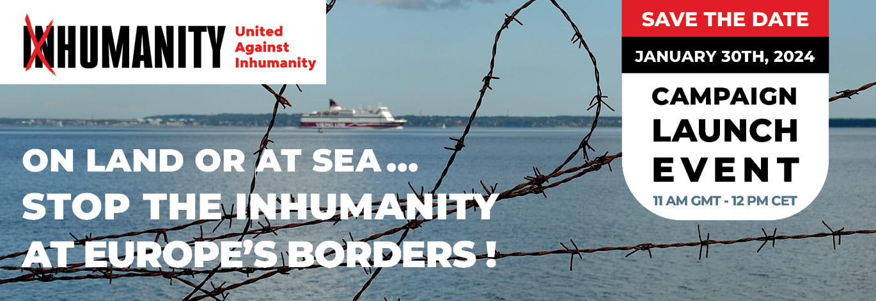
REGISTER HERE

Press release

Stop the inhumanity at Europe’s Borders!

Razor-wire fences and naval blockades. Pushbacks on land and at sea. Physical punishment by border guards, militia forces and vigilante groups. Detention without trial and confinement to squalid camps. Criminalization of aid workers. Deportation deals with rights-abusing states.

These are just a few of the methods that European states are employing to obstruct and deter the arrival of refugees, asylum seekers and migrants from other parts of the world. As a result, people who are on the move and hoping to find security in the region are subjected to many different forms of undignified, inhumane and illegal treatment.

Responding to this unacceptable situation, more than 75 NGOs and civil society organizations have joined forces to launch a campaign titled Stop the Inhumanity at Europe’s Borders!

The campaign will be launched at 11 a.m. GMT on Tuesday 30 January 2024 at Central Hall, Westminster, London, the venue of the first meeting of the UN General Assembly in 1946.

The campaign is based on a Collective Demand that identifies seven specific ways in which European states and the European Union could ensure that people who have made their way to the continent are treated in a fair, just and humane manner.

These demands will be communicated to the leaders of all European states, senior EU officials and to international organizations such as UNHCR and IOM. Over the coming weeks and months, those organizations involved in the campaign at national level will be undertaking a variety of advocacy activities, intended to mobilize support from parliamentarians, opinion leaders, community and faith-based organizations, as well as the general public.

Full details of the campaign, including its objectives, demands and members, can be found by clicking here: https://www.against-inhumanity.org/campaigns/stop-the-inhumanity-at-europes-borders/

The webpage also invites other organizations to join and contribute to this initiative, and provides links to relevant campaign documents in English, French, German, Italian and Spanish.

The campaign is coordinated by United Against Inhumanity (UAI), an independent advocacy organization established by a group of experienced humanitarian workers and former UN officials.

By joining the campaign, UAI and partners are committed to mobilizing action to stop the violence at Europe’s borders, and to ensuring that new and prospective arrivals are treated with the respect to which they are entitled, regardless of their status.

For further information and interviews, please contact:

Jeff Crisp
Email: jefferyfcrisp@gmail.com
Twitter: @jfcrisp
Languages spoken: English

Antonio Donini
Email: antonio.donini@against-inhumanity.org
Languages spoken: English, French, Italian

Jean-Baptiste Richardier
Email: jb.richardier@hi.org
Languages spoken: English, French

Campaign Action Committee
Email: contact@against-inhumanity.org

