- POST 1
STOP THE INHUMANITY AT EUROPE’S BORDERS!
Throughout the world, refugees, asylum seekers and other migrants are being treated in cruel and illegal ways.
Some European states are systematically violating the rights of people attempting to escape from persecution, armed conflict, disasters, and deprivation. At Europe’s borders, such people are confronted with the constant threat of destitution, detention, exploitation, and physical violence. In the worst cases, their lives have been lost, both at sea and on land.
We call on all state authorities to respect fundamental human rights, and act with the humanity that all should demonstrate when interacting with their fellow human beings, and especially so in situations of distress.
👉 Registration for our Campaign Lauch Event in London on the January 30th,2024 (also via Zoom) : https://www.against-inhumanity.org/2024/01/17/collective-campaign-launch-invitation-register-here-and-full-programme/
👉 Read today’s press statement : https://www.against-inhumanity.org/2024/01/24/press-release-stop-the-inhumanity-at-europes-borders/
#StopTheInhumanity #FortressEurope #CivilSocietyMobilisation #HumanRightsMatter #DefendSolidarity #BorderCrisis #StopPushbacksNotPeople

Version Sea
Version Land

- POST 2
INVITATION: STOP THE INHUMANITY AT EUROPE’S BORDERS!
On behalf of 73 organisations, as of today, we warmly invite you to the launch of the Collective Campaign to : Stop the Inhumanity at Europe’s Borders !
SAVE THE DATE : January 30th,2024 (11 AM GMT-12 PMCET)
Event Location : The Chapel in Methodist Central Hall Westminster London SW1H 9NH
This is a free event, and you are welcome to join in person and online.
👉 Please use the link to register via Eventbrite : https://www.eventbrite.fr/e/campaign-launch-stop-the-inhumanity-at-europes-borders-tickets-797724323927
👉 Read the Collective demand : https://www.against-inhumanity.org/wp-content/uploads/2023/12/A-Collective-Demand-Stop-The-Inhumanity-at-Europes-Borders.pdf
👉 Join the campaign : https://www.against-inhumanity.org/campaigns/stop-the-inhumanity-at-europes-borders/
#StopTheInhumanity #FortressEurope #CivilSocietyMobilisation #HumanRightsMatter #DefendSolidarity #BorderCrisis #StopPushbacksNotPeople

Version Sea
Version Land

- Post 3
STOP THE INHUMANITY AT EUROPE’S BORDERS!
On behalf of 73 organisations, as of today, we warmly invite you to the launch of the Collective Campaign to : Stop the Inhumanity at Europe’s Borders !
SAVE THE DATE : January 30th,2024 (11 AM GMT-12 PMCET)
At the Collective campaign launch, we will set out our SEVEN Collective Demands to be presented to all European governments and other responsible intergovernmental organisations.
👉 Read the Collective demand : https://www.against-inhumanity.org/wp-content/uploads/2023/12/A-Collective-Demand-Stop-The-Inhumanity-at-Europes-Borders.pdf
👉 Join the campaign : https://www.against-inhumanity.org/campaigns/stop-the-inhumanity-at-europes-borders/
👉 Registration for our Campaign Lauch Event in London on the January 30th,2024 (available on Zoom) : https://www.against-inhumanity.org/2024/01/17/collective-campaign-launch-invitation-register-here-and-full-programme/
#StopTheInhumanity #FortressEurope #CivilSocietyMobilisation #HumanRightsMatter #DefendSolidarity #BorderCrisis #StopPushbacksNotPeople
Version Sea
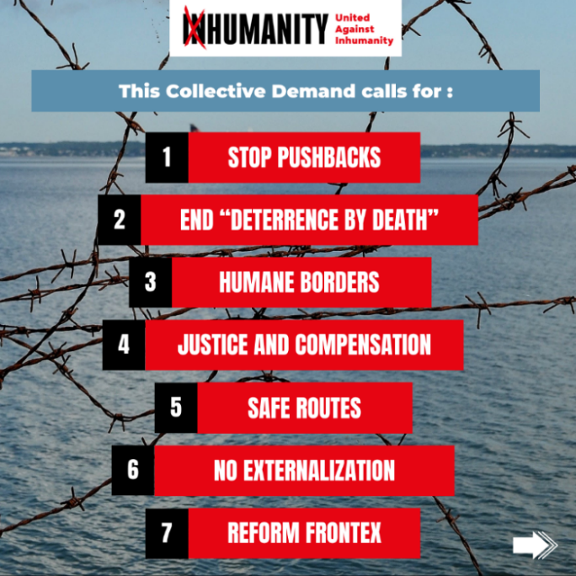
Version Land
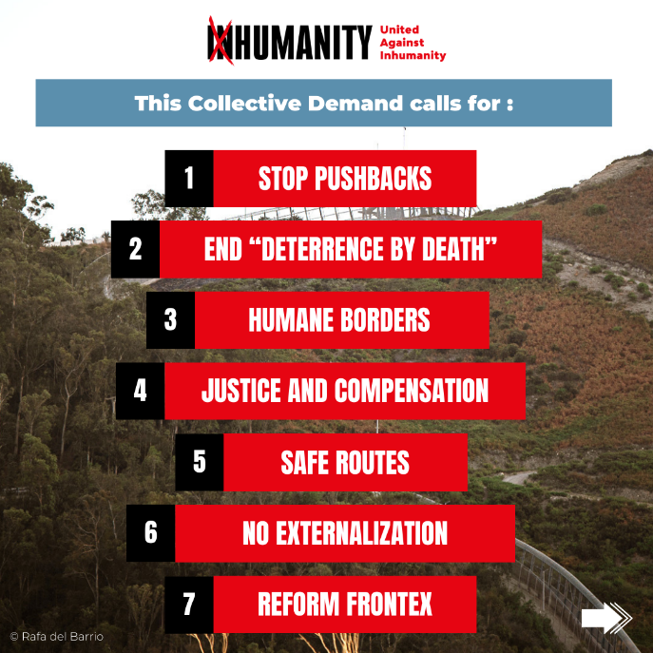

- POST 4
STOP THE INHUMANITY AT EUROPE’S BORDERS!
Throughout the world, refugees, asylum seekers and other migrants are being treated in cruel and illegal ways.
We call on all state authorities to respect fundamental human rights, and act with the humanity that all should demonstrate when interacting with their fellow human beings, and especially so in situations of distress.
👉 Registration for our Campaign Lauch Event in London on the January 30th,2024 (available on Zoom) : https://www.against-inhumanity.org/2024/01/17/collective-campaign-launch-invitation-register-here-and-full-programme/
👉 Read the Collective demand : https://www.against-inhumanity.org/wp-content/uploads/2023/12/A-Collective-Demand-Stop-The-Inhumanity-at-Europes-Borders.pdf
👉 Join the campaign : https://www.against-inhumanity.org/campaigns/stop-the-inhumanity-at-europes-borders/
#StopTheInhumanity #FortressEurope #CivilSocietyMobilisation #HumanRightsMatter #DefendSolidarity #BorderCrisis #StopPushbacksNotPeople

Version Sea
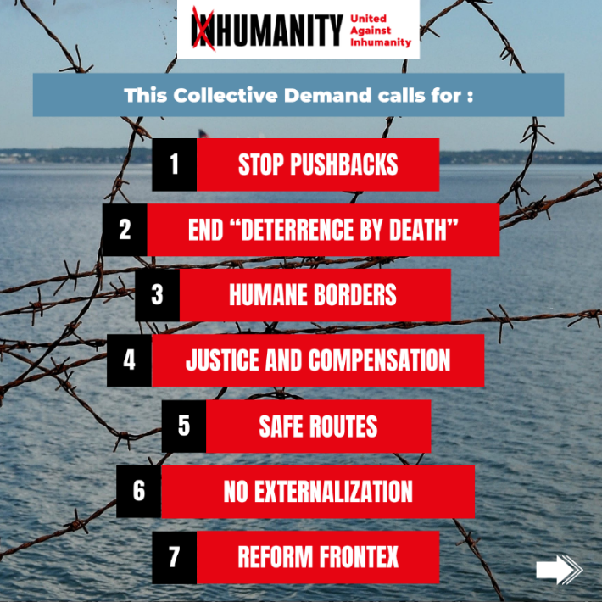
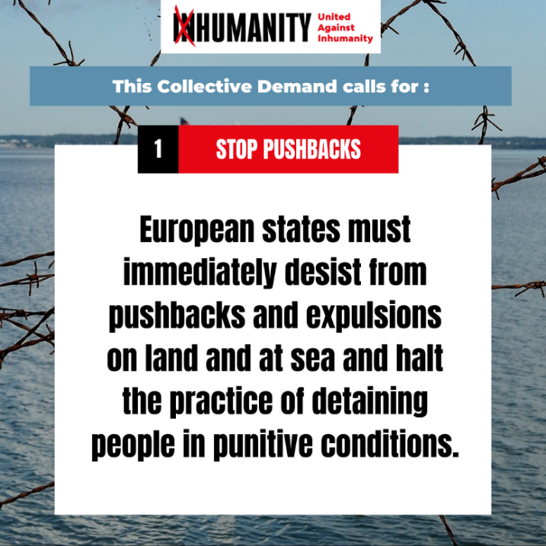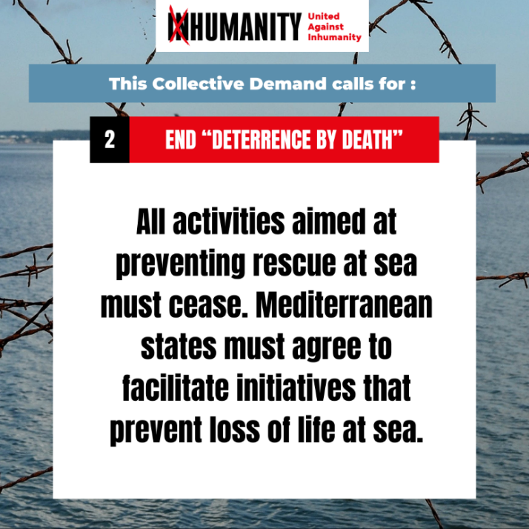
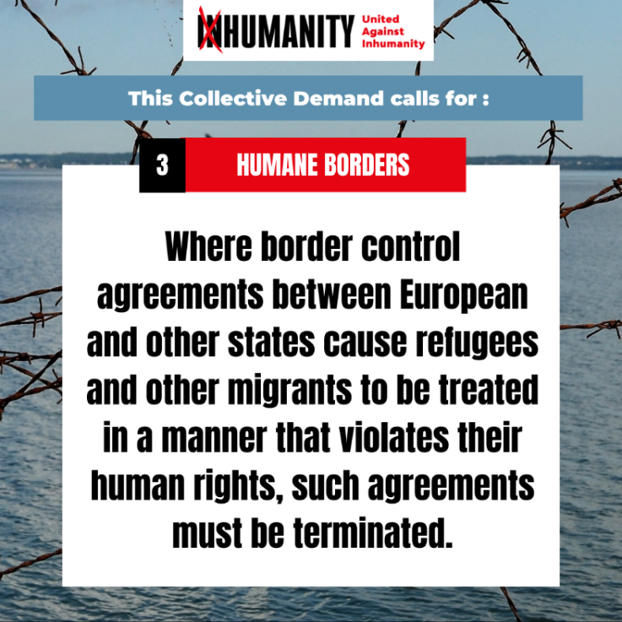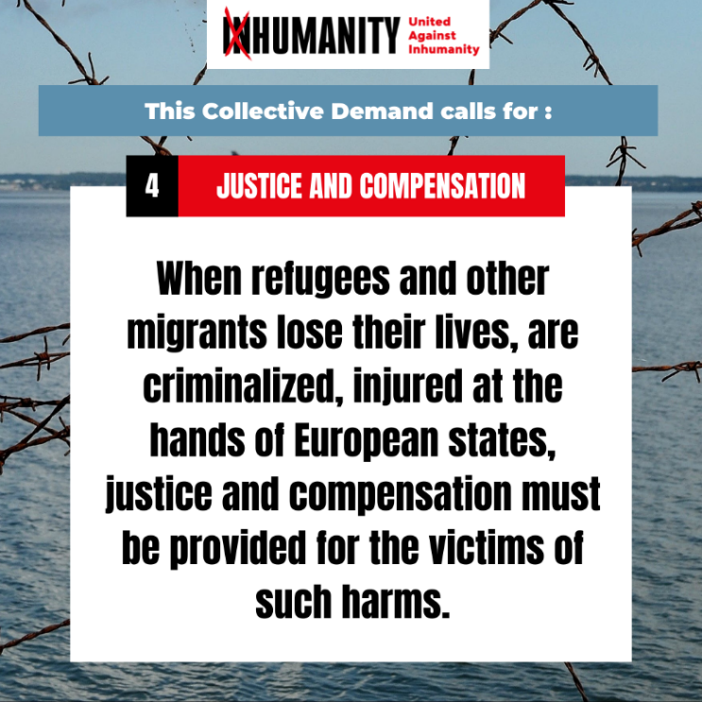
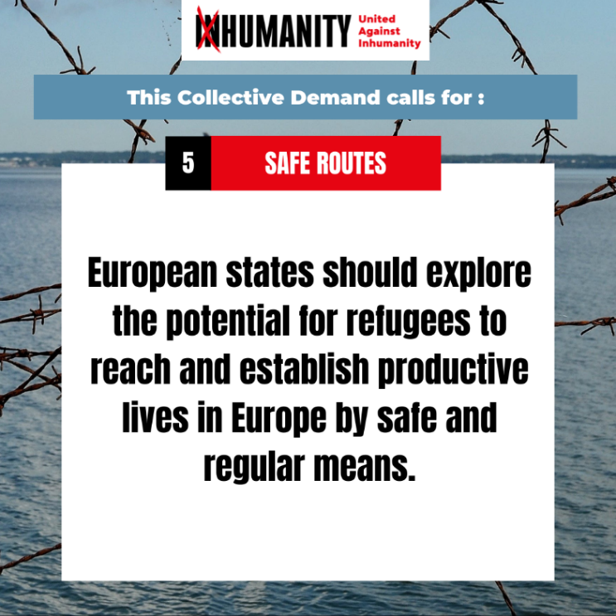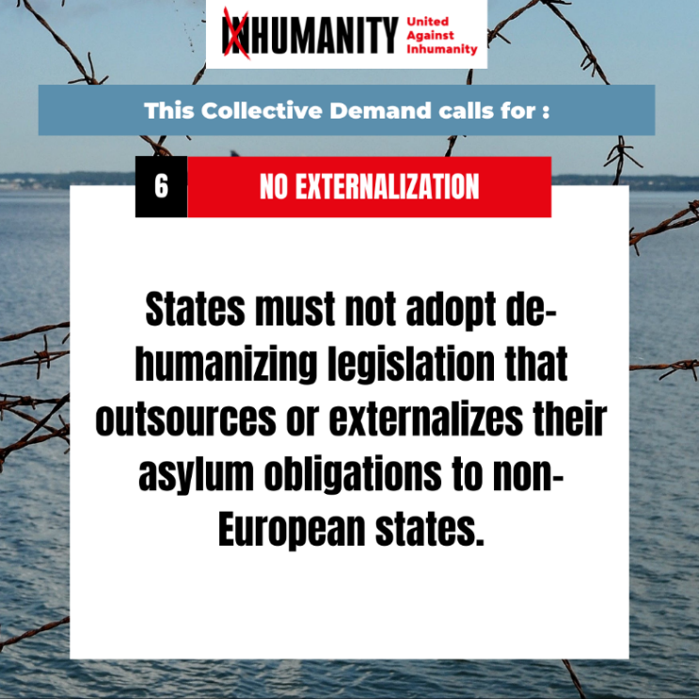
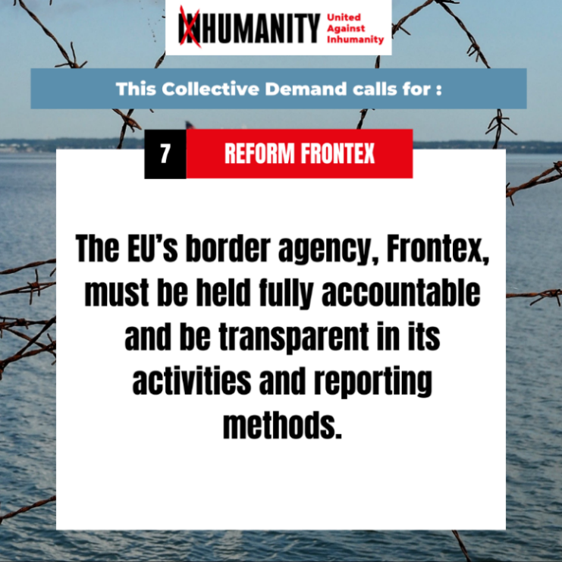
Version Land
